CHEMICAL ENGINEERING TRANSACTIONS  VOL. , 2023 | A publication of
The Italian Association
of Chemical Engineering
Online at www.cetjournal.it

Guest Editors: David Bogle, Flavio Manenti, Piero Salatino
Copyright © 2023, AIDIC Servizi S.r.l.
ISBN 979-12-81206-04-5; ISSN 2283-9216

Demand side management implementation in downstream digestate treatment of a biomethane biorefinery
Lilli Sophia Röderª*, A. Gröngröftª, M. Grünewald^{b}, J. Riese^{b}
ª DBFZ - Deutsches Biomasseforschungszentrum gemeinnützige GmbH, Department of Biorefineries, Leipzig/Germany;
^{b} Ruhr University Bochum, Faculty of Mechanical Engineering, Laboratory of Fluid Separation, Bochum/Germany;
* lilli.sophia.roeder@dbfz.de

For the efficient conversion of fossil-based process energy to renewable energies such as solar and wind, the energy demand of biomass processing must be flexibly adjustable to this fluctuating electricity supply. Adjusting a system's power demand to follow the current power generation is commonly referred to as demand side management (DSM).
One option to increase the flexibility of continuously operated processes entails oversizing the process. DSM strategies result in shutting down a process, and thus electricity being purchased at times of low prices, which can, in turn, lead to monetary benefits. From an economic point of view, this, however, leads to an increase in investment and, thus capital costs. Implementing DSM only serves an economic purpose if these monetary benefits exceed the increase in capital costs. The main goal of this contribution is to present the results of a study on the economic DSM potential for an optimally oversized industrial process. The economic DSM potential for a specific process within a biomethane production plant is calculated in a biorefinery case study. The main results show that in terms of oversizing processes for DSM purposes, a lower value of 100 % was found using dynamic optimization compared to 209.8 % using steady-state optimization. Due to the more realistic assumptions in dynamic optimization, these values are more realizable in real plants.
  - Introduction
The constant expansion of renewable energy sources causes fluctuations in electricity supply. These volatilities in supply combined with unsynchronized demand, inevitably lead to volatility of electricity prices. Faced with such volatility, however, electricity consumers can adjust their energy consumption and thus save electricity costs by synchronizing demand to fluctuating prices. This adjustment is generally referred to as Demand Side Management (DSM).
DSM strategies are based on flexibly switching a process on and off, so that electricity is thereby purchased at times of low prices. This can naturally lead to monetary benefits. For continuously operated processes that are required to produce the same amount of product in a specific period of time, flexibility entails oversizing the process. From an economic point of view, however, this leads to an increase in investment and, thus, capital costs. It is only when these monetary benefits exceed the increase in capital costs that implementing a defined DSM strategy serves an economic purpose.
Röder et al. (2023) have developed a decision support tool that helps to quickly determine the economic suitability of a process for DSM application — a decision support tool for plant design that can be applied to any process. In the past, well-known processes such as different types of electrolysis and desalination plants have often been the focus of calculations involving complex optimization strategies and dynamic simulations of DSM strategies. New processes, such as downstream digestate treatment, can also be investigated with Röder et al.'s developed decision support tool.
This tool is primarily intended for use as a theoretical aid and does not provide an accurate representation of the actual implementation of DSM. In their study, Röder et al. (2023) already applied the decision support tool to the entire biomethane production plant recently described by Etzold et al. (2023) with a cascade of digestate separation processes. Their study showed that the decanter centrifuge has a particularly high economic DSM potential. To achieve a more realistic assessment of the potential benefits, this paper proposes the use of simulation and optimization with Aspen Custom Modeler (ACM).
For the process cascade that was previously analyzed by Röder et al. (2023) a dynamic simulation will investigate whether a comprehensive evaluation of one of the most promising separation steps can reveal more realistic saving opportunities. Thus, this contribution responds to that finding by examining the decanter centrifuge more closely. The methodology consists in employing the decision support tool to ACM and use steady state and dynamic optimization techniques. The optimization is used to determine the sizing of the process and the up- and downstream storage tanks. With known sizes, dynamic optimization may then offer a more viable view of a demand-side management deployment by considering start-up and switch-off times.
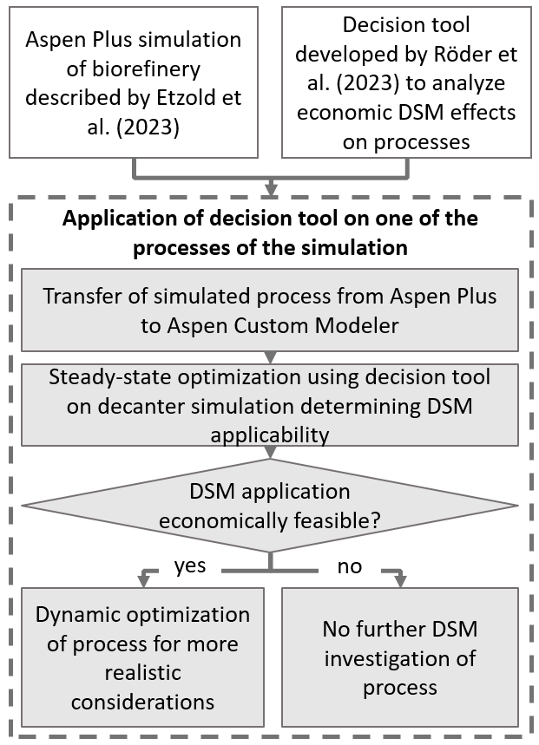
  - Methodology
Figure 1 graphically summarizes the methodology employed in this contribution. White boxes describe the materials used; grey boxes describe the method by which new results were obtained; and the diamond represents a decision made.
Using results from the pre-investigations of Etzold et al. (2023) and Röder et al. (2023) a steady-state optimization enables a steady-state optimization of the dimensioning of the process and the upstream and downstream buffer tanks. If the DSM application is economically feasible, then the optimization will find an ideal oversizing of a process for maximizing flexibility within economic boundaries. With these calculated values, a dynamic optimization can be performed that reacts to changing electricity prices and schedules the operation of the process. For known oversizing factors dynamic optimization then provides a more realistic view of a DSM operation by taking start-up and switch-off times into account.
    - Process simulation of a the digestate separation step
Within the case study plant the decanter centrifuge is located down- and upstream of other separation processes that are operated continuously. A simplified flowsheet of the investigated process is provided in Figure 2.
Figure 1: Graphic summary of method used in this contribution.
In the Aspen Plus simulation described by Etzold et al. (2023), the decanter process was simplified using a separator block. Partially clarified fermentation residue comes from an upstream separation step. This digestate mixture with a mass flow of 279 kt/y consists of 97.92 wt.% water (W), 1.45 wt.% residual organic dry matter (O), 0.03 wt.% phosphorus (P), 0.06 wt.% potassium (K), and minor amounts of nitrogen (N). The split fractions of the liquid stream of the decanter were set to W = 0.82, O = 0.38, P = 0.12, K = 0.89, and N = 0.84 at their design point. Pressure or temperature increase were not considered in the simulation within the decanter centrifuge. Volume and oversized capacity of storage tanks and decanter centrifuge were calculated by the simulation.
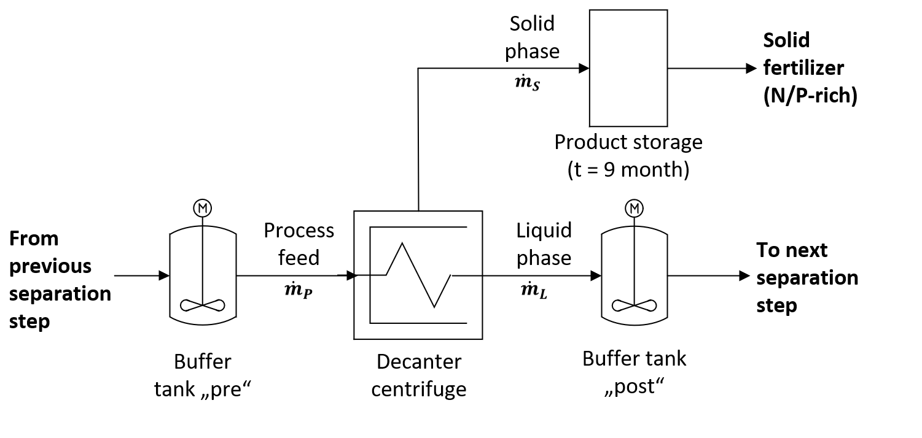
Figure 2: Simplified flowsheet of decanter centrifuge process under consideration.
    - DSM assessment decision support tool
The decision support tool developed by Röder et al. (2023) was used to evaluate the most critical economic parameters to decide on a DSM implementation in this continuously operated separation process. The tool is based on a multistep analysis of processes, investigating mass flows, energy demand, theoretical DSM potential, and most importantly, economic aspects of DSM implementation. It evaluates and ranks processes concerning their economic DSM potential and determines whether DSM implementation is economically viable. A comprehensive description of the decision support tool can be found in Röder et al. (2023). The following formulas to determine monetary benefits in operational expenditure and capital cost increase in the steady-state optimization step from the proposed methodology were defined, assuming the possibility of a complete switch-off of the process during flexible operation:
$C_{opex}\left(F_{os}\right)=\left( a_{year}-b_{year}*\left(τ-\frac{τ}{F_{os}+1}\right)\right)*EPC*τ_{oph}$ | (1)
$$C_{capex}(F_{os})= I_{p}*r_{p}*{(F_{os}+1)}^{R_{P}}+I_{buf}{*\left(\frac{\left({\dot{m}}_{buf}\right)*\left(τ-\left(\frac{τ}{F_{os}+1}\right)\right)}{V_{ref}}\right)}^{R_{buf}}$$ | (2)
$$C_{totex}\left(F_{os}\right)=C_{opex}\left(F_{os}\right)+ C_{capex}(F_{os})$$ | (3)
$C_{capex}$ | Capital expenditure per year
$C_{opex}$ | Operational expenditure per year
$C_{totex}$ | Total expenditure without DSM implementation
$F_{os}$ | Oversizing factor [%]
$a_{year}$ | Maximum average electricity price of specific period of time [€/kWh]
$b_{year}$ | Electricity price variation of specific period of time [€/(kW*h2)]
$τ$ | Period of time [h]
$EPC$ | Electric power consumption of process
$τ_{oph}$ | Yearly operating hours [h/a]
${\dot{m}}_{buf}$ | Mass flow considered for buffer tank
$I_{p}, I_{buf}$ | Investment for process, buffer tank [€]
$r_{p}$, $r_{buf}$ | Expense ratio of process, buffer tank [%/a]
$R_{p}$, $R_{buf}$ | Economies of scale of process, buffer tank [-]

The $F_{os}$ of a process is dependent on the switch-off time $(t_{app})$, according to the following formula:
$$F_{os} =\frac{t_{app}}{τ-t_{app}}$$ | (4)
Cherry-Picking (CP) values, obtained from the German power market database toolbox (Martin Dotzauer), describe average electricity prices, and how they drop if electricity peaks are avoided. The longer a process can be switched off, the lower the average annual electricity price. A more thorough description of this effect can be found in (Röder et al. 2023). The rate at which the average price decreases, is dependent on the switch-off time$(t_{app})$, is described by $b_{year}$. A lower average electricity price then leads to lower $C_{opex}$. If a process is operated continuously, thus $t_{app}=0$, the average yearly electricity price equals $a_{year}$.
The $F_{os}$ was calculated so that at the end of the day, the same amount of cumulative product flow remains, although the process is turned off for $t_{app}$. A longer $t_{app}$ and, thus, greater $F_{os}$ also causes a rise in investment for process $I_{p}$ and buffer tank $I_{buf}$ and thus influences the $C_{capex}$ function.
The sum of $C_{capex}$ and $C_{opex}$ describes the total expenditure $(C_{totex})$. The DSM implementation is economically infeasible if the decrease in $C_{opex}$ does not exceed the increase in $C_{capex}$ with increasing $F_{os}$. If this function, however, forms a minimum in a specific range of the $F_{os}$, then an optimal $F_{os}$factor can be found at which a process will benefit most from the use of DSM.
    - Development of steady-state optimization strategy in aspen custom modeler
To make the decanter more flexible, the process must be oversized. At the same time, the incoming product stream is stored so that the upstream separation process can run continuously. The same applies to the outflowing liquid phase, which is pumped to a subsequent separation stage in the cascade. The emerging solid phase is sold as a product - solid fertilizer. It is assumed that there already is a large storage area for the end product.
The optimal size of the "pre" and "post" buffer tanks and the $F_{os}$capacity of the decanter centrifuge were calculated in the ACM model according to the previously described decision support tool. The parameters needed for the calculation of the optimal oversizing factor are listed in Table 1, based on the contributions by Etzold et al. (2023) and Röder et al. (2023):
Table 1: Parameters needed for the calculation of the optimal oversizing factor.
Parameter |  | Unit | Value
$a_{year}$ | Maximum average price of specific year | [€/kWh] | 0.2409
$b_{year}$ | Electricity price decrease of specific year | [€/(kW*h2)] | 0.0038
${SEC}_{p}$ | Specific electricity consumption of process | [kWh/t] | 5
${\dot{m}}_{P}$ | Annual mass flow of process | [kt/y] | 279
$I_{p,ref}$ | Investment costs for reference process | [k€] | 197
$I_{buf,ref}$ | Investment costs for reference buffer tank | [k€] | 171a
$V_{buf,ref}$ | Volume of reference buffer tank | [m³] | 600a
$r_{p}$, $r_{buf}$ | Expense ratio of process and buffer tank | [%/a] | 11
$R_{P}$ | Economies of scale factor of process | [-] | 0.6
$R_{buf}$ | Economies of scale factor of buffer tank | [-] | 1
ªSource: Peter et al. (2006)

For the initial steady-state optimization, the decanter model was transferred from Aspen Plus to the dynamic simulation equivalent ACM. To make optimization possible, all decision support tool formulas were implemented in the flowsheet of the ACM model. With the ACM optimization tool, the optimal $F_{os}$was calculated first. The objective function – the total expenditure – was to be minimized. The control variable was $F_{os}$. The period considered was one day with initially one control variable element.
The process is suitable for the DSM application if the steady-state optimization finds an optimal $F_{os}$value. With this optimized $F_{os}$value, a dynamic optimization was carried out. The steady-state optimization can thus find a very accurate value for the $F_{os}$ and $t_{app}$. From the point of view of a plant design, this may not seem practical since oversizing to such a degree of accuracy is not possible. For this reason, dynamic scheduling was also carried out for comparison. This dynamically optimizes a flexible switching on and off of a decanter depending on electricity prices at different pre-defined $F_{os}$.
    - Development of dynamic optimization strategy in aspen custom modeler
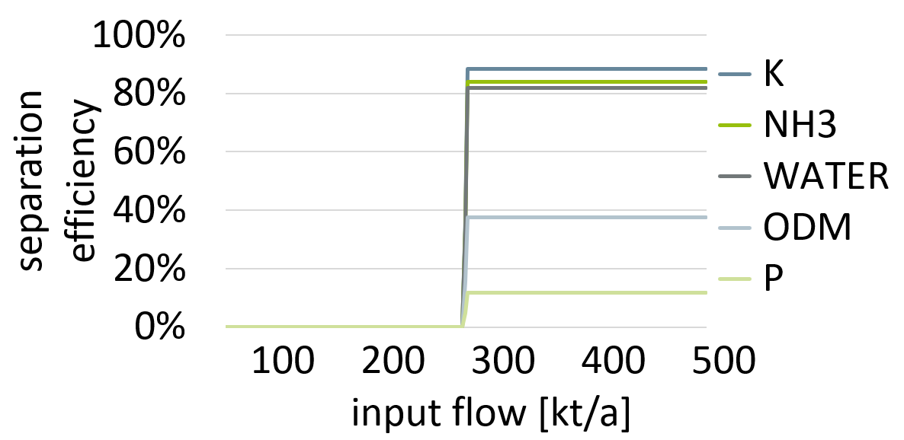
The dynamic optimization scheduled the switch-on and off time of the decanter centrifuge according to time-dependent electricity prices. For this scenario, 24 time-data points with the CP values of the German power market database toolbox (Martin Dotzauer) were inserted, following an average daily course of electricity prices for 2022.
To model an on/off operation of the decanter in ACM, a step function was inserted that manipulates the separation efficiencies of the decanter. The separation efficiencies in the decanter were calculated as a function of the flow rates. This effect can be seen in Figure 3. The decanter, therefore, only separates when the design operating point is reached. In the example of Figure 3 with no oversizing the decanter only operates above an input flow of 279 kt/y.
Figure 3: Separation efficiency dependent on input flow.
To represent a more realistic operation of the decanter, the following assumptions were considered in the dynamic simulation: Switch-on and off times are one hour each. The process can only be switched on and off in hourly intervals. $F_{os}$ values are limited to steps of 25 %.
During the dynamic optimization the process was automatically switched on and off when this is most suitable according to the electricity prices. The objective function $C_{totex}$ was to be minimized. The control variable was the feed flow with operation limits between 0 t/hr and $\dot{m}*(1+F_{os}).$The period considered was one day with 24 variable elements. As a constraint, it was specified that the cumulated liquid product stream should remain constant at the end of the day. The optimized dynamic scheduling was carried out for $F_{os}$ of 75 %, 100 %, 150 %, and 200 % with expected $t_{app}$ of 10 h, 12 h, 14 h, and 16 hr.
  - Results and Discussion
The results of the steady-state optimization show that the decision support tool presented by Röder at al. (2023) could be transferred to ACM. The incorporated decision support tool formulas allow optimization with respect to an ideal $F_{os}$. With the new values for CP and the steady-state ACM optimization, the optimal $F_{os}$, $t_{app}$, and $C_{totex_min}$, can be calculated. These values are listed in Table 2. The business as usual case (BAU) is compared with that one of DSM implementation where the optimal oversizing is found through steady-state optimization.
Table 2: Steady-state optimization results comparing DSM implementation to business as usual scenario.
Parameter | Description | Unit |  | BAU |  | DSM
${EPC}_{p}$ | Electric power consumption of process | [kWh/h] |  | 174 |  | 174
$I_{buf}$ | Investment for buffer tank | [k€] |  | 0 |  | 95
$I_{p}$ | Investment for process | [k€] |  | 197 |  | 388
$C_{opex}$ | Operational expenditure per day for process | [€/d] |  | 859 |  | 681
$C_{capex_buf}$ | Capital expenditure per day for buffer tank | [€/d] |  | 0 |  | 29
$C_{capex_P}$ | Capital expenditure per day for process | [€/d] |  | 59 |  | 117
$C_{totex_min}$ | Total expenditure per day for process and buffer tank | [€/d] |  | 918 |  | 821
$F_{os}$ | Oversizing factor |  | [%] |  | 0 | 209.8
$t_{app}$ | DSM application time |  | [h] |  | 0 | 16.9

The steady-state ACM optimization found an optimal $F_{os}$ at 209.8 %. This means that the process can be switched off for the most expensive 16.254 h of each day. It also means that buffer tanks are sized in a way that they could store in- and outflow substrate during these 16.254 h of switch-off. The investments for the 3.098-time larger process and buffer tank are 286 k€ higher, resulting in an 86 €/d higher $C_{capex}$. At an $F_{os}$ of 209.8 %., the average yearly electricity costs can be reduced from 0.2408 to 0.1791 €/kWh leading to a reduction of $C_{opex}$ of 178 €/d. The $C_{totex}$ can therefore be reduced from 918 to 821 €/d.
The goal of the steady-state optimization is to figure out whether DSM implementation seems economically feasible. These results show that this is the case. A more representative dynamic scheduling with $F_{os}$ factors close to the steady-state optimization results can now be performed for four different $F_{os}$factors. Figure 4 shows the results of the dynamic optimization.

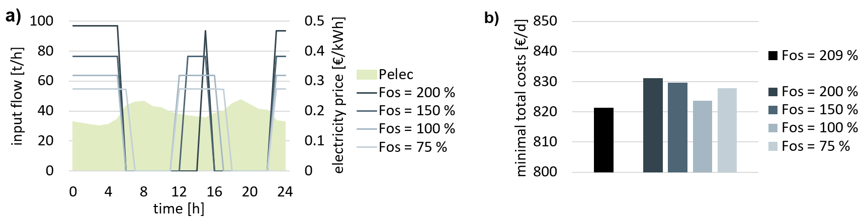
Figure 4: Optimized schedule of input flow (a) and resulting minimum total costs per day (a) for four different oversizing factors.
Figure 4a shows the optimized schedule of input flow in t/h for the four different $F_{os}$ factors. For an $F_{os}$ of 200 %, closest to the steady-state optimization, there is a high operation flow of the decanter centrifuge at the beginning and end of the day and a peak operational flow at midday when the electricity prices are low. The whole process is switched off for 16 hours on the examined day. The resulting $C_{totex}$value is shown in the Figure 4b. The reference value from the steady-state optimization - 821 €/d - is represented by the black bar on the far left. The value of the dynamic optimization with an $F_{os}$ of 200 % and $t_{app}$of 16 h is significantly higher at 831 €/d.
The same scheduling optimization was performed for 150 %, 100 %, and 75 % oversizing. The input flow, which tends to occur in the favorable morning and evening hours and also develops a peak during midday, which can again be seen in Figure 4a. The bar diagram in the Figure 4b represents the $C_{totex}$ values of the respective dynamic optimization. The resulting values for $C_{totex}$ are lower for all $F_{os}$ factors than those for 200 %, where optimal oversizing was initially assumed. The lowest value is obtained with an $F_{os}$ of 100 %. This more realistic perspective on the dynamic scheduling problem explains the differences between steady-state and dynamic oversizing. In the steady-state simulation, the switch-on and off times of the processes were not considered. This means that the buffer tanks are even more significant than when immediate switch-off is assumed. The dynamic investigation also introduces a certain inertia into the process. As a result, power is still consumed during switch-on and switch-off, which may fall into non-optimal electricity price periods. Considering hourly intervals also allows for a less precise switch-off time than would be the case with quarter-hourly intervals or even higher time discretization.
  - Conclusion and Outlook
In this contribution a previously developed decision support tool to calculate the economic demand side management potential of a process is applied to a decanter centrifuge. The results presented above show that the decision support tool to optimize steady-state economic demand side management feasibility can also be used for the optimization of dynamic system operation. The steady-state optimization determines the dimensioning of the process and the upstream and downstream buffer tanks. For known dimensions, the dynamic optimization can then provide a more realistic view of a demand side management operation by taking start-up and switch-off times into account.
Using the example of a downstream separation unit in the production of biomethane showed that steady-state optimization can be performed with exact values of 209.8 % oversizing and a switch-off time of 16.254 hours. From a plant operator's point of view, this may need to be clarified since oversizing with such accuracy will not be possible. However, trends can be deduced through further investigations with known initial variables.
The same analysis was performed using dynamic optimization to incorporate optimal operation. In this way, a more realistic operation of the process could be considered: start-up and switch-off times were considered, and a realistic oversizing increment was given. The value of total expenditure per year was not further minimized, but the initial theoretical consideration of oversizing is reflected. An optimal scheduling could be found for different oversizing factors with the dynamic investigation. A new ideal oversizing was found at 100 %.
The next conceivable step would be to consider sample days, rather than average values, with actual electricity prices and different price profiles accounted for. Thus, demand side management strategies could be examined on days with peak and flat electricity price rates. Furthermore, because the decanter is located in the middle of a separation cascade, future investigations of the use of demand side management in biorefineries will consider the effects of a flexible cascade. The aim is not to study just one process but the interactions of processes’ flexibility with a dynamic simulation approach. The goal is to save further costs on buffer storage by simultaneously switching processes on and off in a cascade of separation processing. This type of indirect DSM causes a reconsideration of the flexibilization of processes initially considered unsuitable for flexible operation.
Publication bibliography
Etzold, Hendrik; Röder, Lilli Sophia; Oehmichen, Katja; Nitzsche, Roy (2023): Technical design, economic and environmental assessment of a biorefinery concept for the integration of biomethane and hydrogen into the transport sector. In Bioresource Technology Reports, Vol.22., Article 101476. DOI: 10.1016/j.biteb.2023.101476
Martin Dotzauer: German power market database toolbox / gpm_dbtb · GitLab. Available online at https://gitlab.com/M.Dotzauer/gpm_dbtb, accessed 24.08.2022.
Röder, Lilli Sophia; Gröngröft, Arne; Etzold, Hendrik; Grünewald, Marcus; Riese, Julia (2023): Decision support tool to evaluate the economic demand side management potential in continuous industrial processes - a biorefinery case study. In Chemical Engineering Science (under review).
Peters, M.; Timmerhaus, K.; West, R. (2006): Plant Design and Economics for Chemical Engineers. 5th ed.: Mcgraw-Hill Publ.Comp. Available online at http://www.mhhe.com/engcs/chemical/peters/data/.

